Computer Language Diagrams

Assignment in a Diagram
The principle of assignment is explained in the article Assignment. This article demonstrates the expression of it in a diagram.

There are several types of assignment, for instance value assignment and object assignment. All assignments are displayed as a call to a special system method: the assignment methods. An assignment method have two parameters: the source and the target.

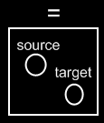

The source is an input parameter, the target is an affected throughput parameter. The parameter type is shown as follows in a diagram of the assignment method definition:

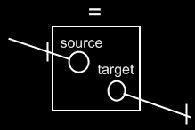

The lines with access marks, are an implicit notation, explained in the article Input, Output, Throughput in a Diagram. The access marks point out the direction of the assignment. The souce goes in and the target comes out. The notation looks clearer in a call to the assignment method, compared to the notation of the definition of the assignment method.

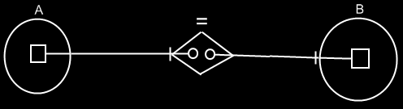

Object A is assigned to object B. The direction of the parameter is towards the access marks: to the right.

Because assignment is so fundamental and common, it may deserve a more basic notation, like the following:



Essentially, part of the notation is just left out. You don’t see the source and target as parameters, and you don’t see the assignment method as part of the objects.

See also: Assignment, Input, Output, Throughput in a Diagram

Author & Copyright: Jan-Joost van Zon Date: May 25, 2008 – May 25, 2008 Location: Oosterhout, The Netherlands Status: Finished

